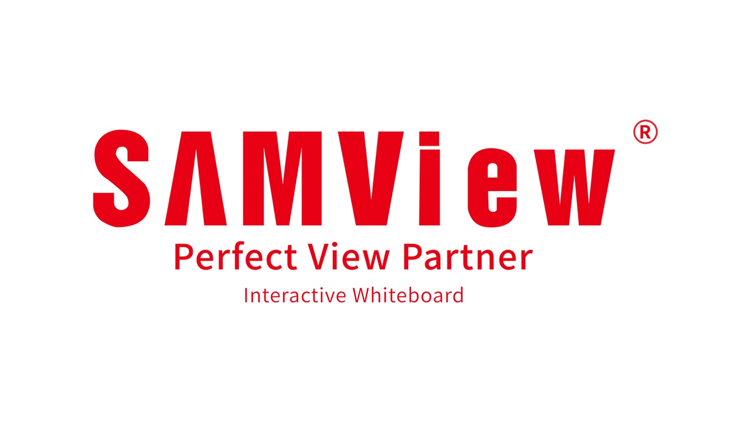 | Issued by  Alibaba Appliances Sdn. Bhd.

Dealer Company Background Form
Supporting information for the Samview dealer and sales agent application
Purpose This add-on form helps Alibaba Appliances Sdn. Bhd. verify the applicant’s legal status, ownership, business history, financial standing and operating capability. Provide complete information and attach clear, current copies of the requested documents.

1 Application Reference
Applicant company name
Main application date
Contact person
Mobile and email
Proposed appointment | ☐ Dealer ☐ Sales Agent ☐ Project Partner ☐ Installer or Integrator

2 Company Registration Information
Registered company name
SSM registration number
Former company name | If applicable: ______________________________________________
Date of incorporation
Business structure | ☐ Sdn. Bhd. ☐ Enterprise ☐ Partnership ☐ Other: __________________
Nature of business
Registered address
Operating address
Paid up capital | RM ____________________ If applicable

3 SSM and Statutory Documents
☐ SSM registration or incorporation certificate | ☐ Latest SSM company or business profile
☐ Current directors and shareholders information | ☐ Registered address information
☐ Company constitution if applicable | ☐ Change of company name document if applicable
☐ SST registration certificate if applicable | ☐ LHDN tax registration information
☐ MOF registration if applicable | ☐ CIDB registration if applicable
☐ Relevant local authority business licence | ☐ Other industry licence or certification

4 Directors Owners and Beneficial Ownership
Full name | NRIC or passport | Position | Ownership percent | Nationality

5 Business Background
Year business commenced
Core products and services
Main customer sectors | ☐ Education ☐ Government ☐ Corporate ☐ Retail ☐ Hospitality ☐ Other
Main operating locations
Number of employees | Sales: ______ Technical: ______ Administration: ______ Total: ______
Showroom or office | ☐ Owned ☐ Rented ☐ Home office ☐ No permanent premises
Warehouse facilities | ☐ Own warehouse ☐ Third-party warehouse ☐ None
Related companies | Names and relationship: _____________________________________________

6 Current Brand and Channel Relationships
Brand or supplier | Product category | Relationship | Since

7 Financial and Banking Information
Bank name
Bank account name
Bank account number
Estimated annual turnover | RM ____________________ Financial year: ____________________
Credit facilities | ☐ Yes ☐ No Bank or provider if yes: ______________________________
Requested supporting records | ☐ Bank confirmation ☐ Latest financial statements ☐ Recent bank statements if requested

8 Business References
Company | Contact person | Telephone or email | Relationship and years

9 Background Declarations
☐ No director or owner is currently an undischarged bankrupt
☐ No winding-up or insolvency proceeding is pending against the applicant
☐ No material legal action is pending against the applicant
☐ No dealership or distributorship has been terminated for misconduct
☐ No director or owner has been convicted of fraud or dishonesty
☐ No conflict of interest with Alibaba Appliances Sdn. Bhd. has been identified
If any statement above cannot be confirmed, provide details including dates, parties, status and outcome.
________________________________________________________________________________
________________________________________________________________________________
________________________________________________________________________________

10 Applicant Declaration and Consent
I or we confirm that the information and documents supplied are true, complete and current. We authorise Alibaba Appliances Sdn. Bhd. to verify the information with SSM, banks, trade references and other lawful sources where necessary for evaluating this application. We understand that sensitive documents will be used for assessment, compliance and record keeping, subject to applicable data protection requirements. We will promptly notify Alibaba Appliances Sdn. Bhd. of any material change. Providing false, misleading or incomplete information may result in rejection, suspension or termination of any appointment.
Authorised signatory name
Position
Signature
Company stamp
Date

11 For Samview Malaysia Verification Use
Document or check | Received | Verified | Remarks
SSM registration certificate | ☐ Yes ☐ No | ☐ Yes ☐ No
Latest SSM profile | ☐ Yes ☐ No | ☐ Yes ☐ No
Directors and ownership | ☐ Yes ☐ No | ☐ Yes ☐ No
Address and licence | ☐ Yes ☐ No | ☐ Yes ☐ No
Bank verification | ☐ Yes ☐ No | ☐ Yes ☐ No
Financial records | ☐ Yes ☐ No | ☐ Yes ☐ No
Trade references | ☐ Yes ☐ No | ☐ Yes ☐ No
Background declarations | ☐ Yes ☐ No | ☐ Yes ☐ No
Verification outcome |  | ☐ Satisfactory ☐ More information required ☐ Refer for management review
Reviewed by |  | Name: ____________________ Position: ____________________
Signature and date |  | Signature: ______________________________ Date: ____________________

